**Name : رضوه محمد ابراهيم امام خليفه**

**B.N: 347**

**Date : 8/7/2020**

**Topic: Programming languages**

**Github link :** [**https://github.com/radwamuhammed/ece001**](https://github.com/radwamuhammed/ece001)

**Github page :** [**https://radwamuhammed.github.io/ece001/**](https://radwamuhammed.github.io/ece001/)

**Application brief**

* **Programming language is a set of commands that are written according to specific rules, and it is the language of communication between the computer and the programmer as it directs them to make a specific code or order.**
* **Programming languages also have many uses. They are used in creating websites, video games, databases, and others**
* **Examples of programming languages are C , C# , C++ , Java , SQL and Python**
* **I have chosen this topic because I am very passionate about electronics and communications and I always like research and learning about these subjects as self-skills and I saw that this research would be a good opportunity for me to learn something new.**
* **Screenshots**

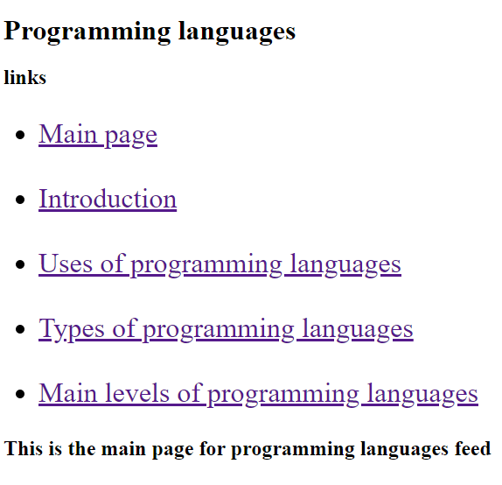

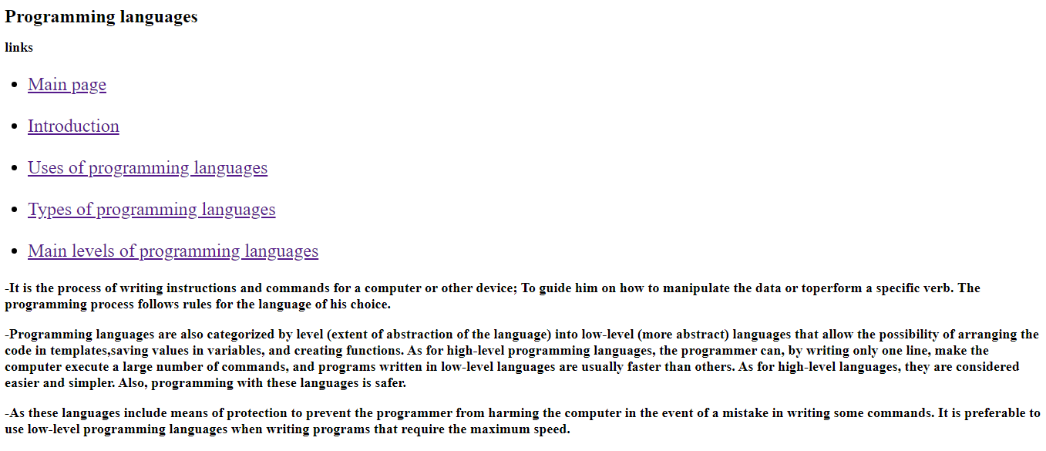

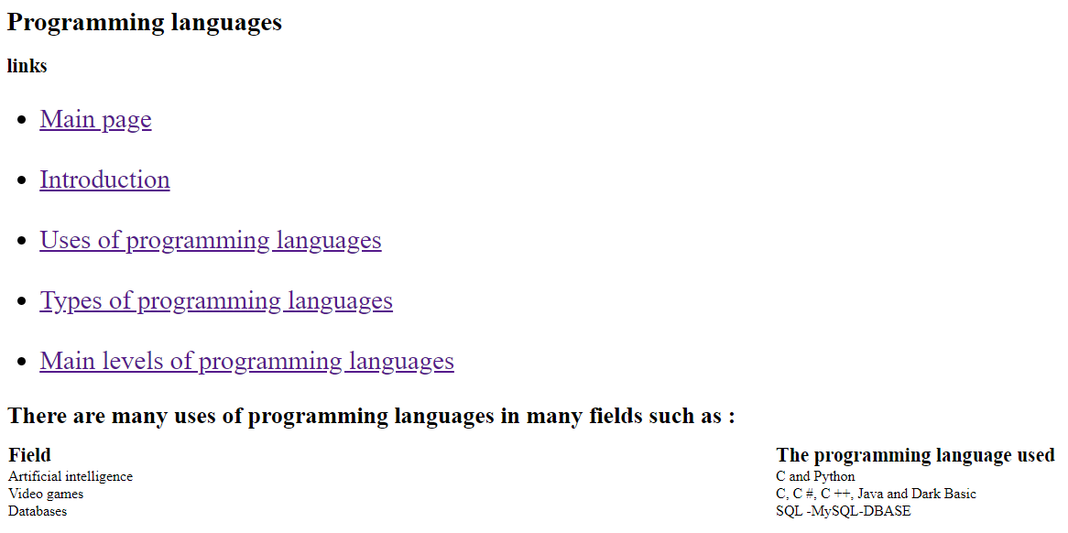

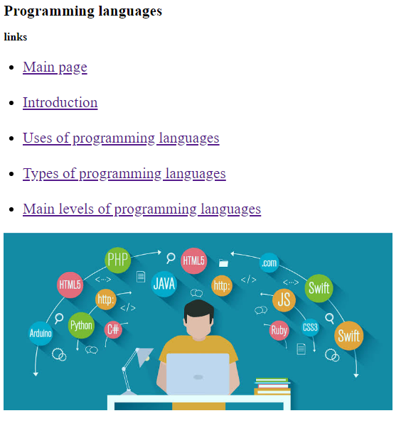

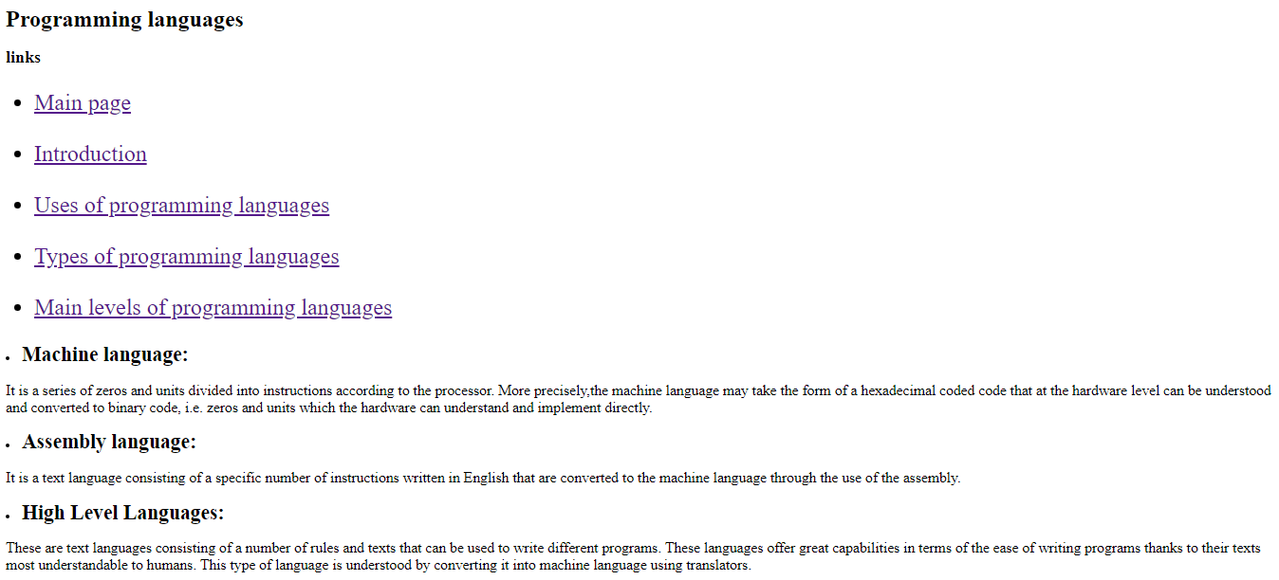

* **Source code:-**

